Report

After spending 1 MD (8h), I decided to sum up my work and send it for a review:

1. Create C# project that reads CSV file and generates database with data using Entity Framework. I realize this part was supposed to be done using Integration Services Project. (3h)
2. SQL Config – add SQLServerMSAS user group to SSAS users so the solution may work (3h)

<http://sqlserverandme.blogspot.com/2013/04/a-solution-for-ssas-deployment-error.html>

1. Play with CUBE, create measures from task, write report document (2h)

Usage:

In the solution launch C# project that will generate database from the file (this could take a few minutes, because of constraint generation for each fact table. Then check the data on BI project.

Please remember this was my **first** Data Warehouse related project since 2013.

Database generated from C# solution – proper foreign key constraints and valid data

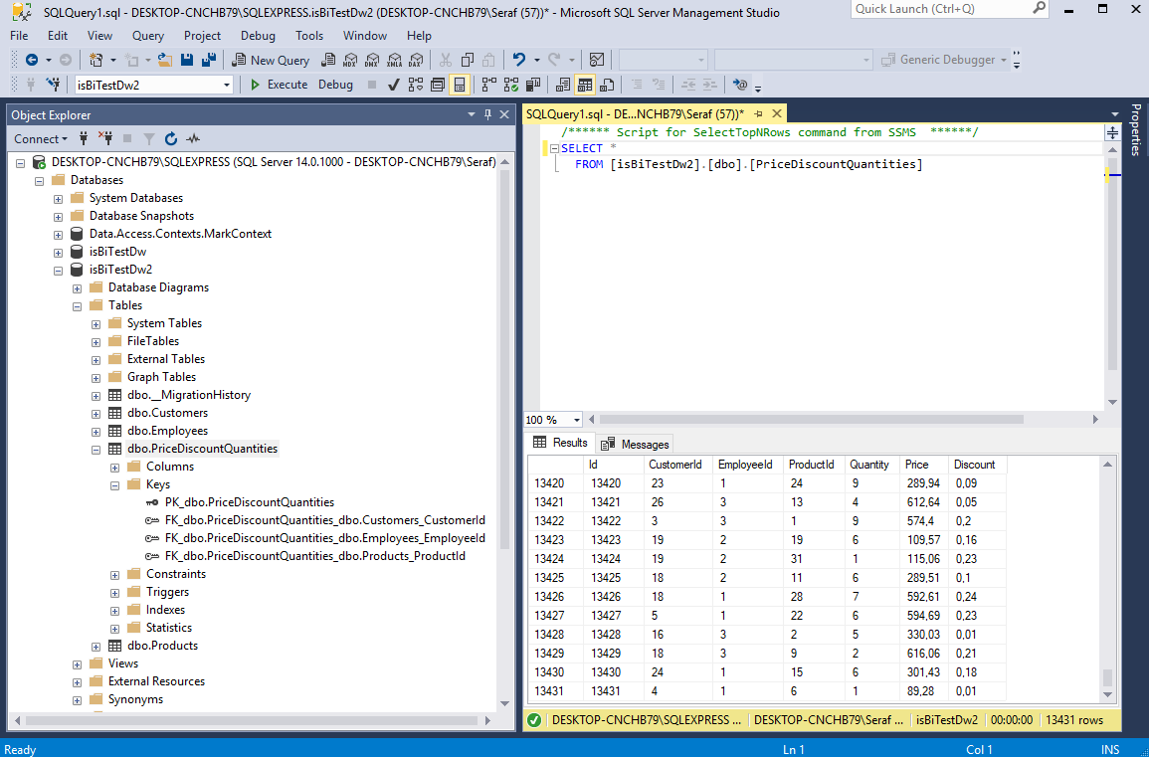

Database loaded as Data Source

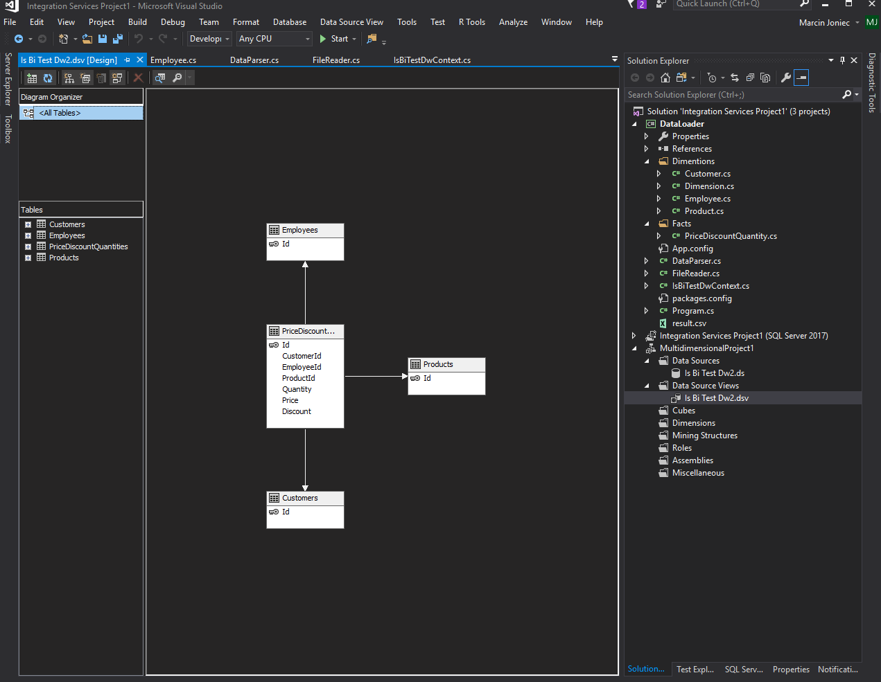

Olap Measures

